


Residential and small business community outreach package

February 2026
We thank you, as one of our trusted community members, for sharing our content and digital assets with your audiences – including residents, customers and employees – to help amplify our key messages in your email communications, websites, newsletters and social media.



Best practices when using SDG&E’s content

- SDG&E® logo
You’re welcome to mention our name; but, due to legal requirements, please do not use our logo in any marketing materials that you create. It’s okay to reshare our public posts, which you’ll find on Facebook.com/sdge, Instagram.com/sdge and X.com/sdge. The graphics we provide in this document for social posts include our logo, and that is okay to include in your communications.

- Social posts
PLEASE ONLY USE THE INCLUDED SOCIAL POSTS IN THE SAME MONTH AS IN THIS PACKAGE

- Videos
We have a library of videos you can share in your communications when you visit youtube.com/c/SanDiegoGasElectric/videos. If you’d like to sort our videos by topic, visit youtube.com/c/SanDiegoGasElectric. Some videos are in Spanish. You’ll see some on TV, too!

- Follow us
Find us on Facebook, Instagram, X, YouTube and LinkedIn. When sharing our digital assets and content, feel free to tag SDG&E’s social media and direct your audience to sdge.com.

If you have any questions, comments or feedback, email Lynne Pelzek @ lpelzek@sdge.com.

Message funded by ratepayers.

© 2026 San Diego Gas & Electric® Company. All copyright and trademark rights reserved.

This month’s topics:
Winter energy-saving tips for home and small businesses, storm preparedness tips, customer assistance programs, energy saving for business.

Table of contents
Article: 10 tips to reduce heating costs this winter, p. 4
Social posts: 10 tips to reduce heating costs this winter, p. 5
Article: Storm ready: Tips to keep you safe, pp. 6 – 7
Social post: Storm ready: Tips to keep you safe, p. 7
Article: Customer assistance programs, pp. 8 – 9
Social posts: Customer assistance programs, p. 9
Article: Small business energy-saving tips, pp. 10 – 11
Social posts: Small business energy-saving tips, pp. 11 – 12

Residential articles + social posts

Article: 10 tips to reduce heating costs this winter
If you’re spending more time at home this winter, you could see an increase in your energy use which may lead to a higher bill. But there are ways to reduce use and save with these tips.
- Being on the right pricing plan can make a difference on your bill. Compare pricing plans to ensure you are on the best plan for your household at sdge.com/pricing.
- Use appliances before 4 p.m. or after 9 p.m. when demand for power is less and costs are lower.
- Use exhaust fans sparingly. Your bathroom fans and oven hoods are overlooked sources of heat loss in the winter because they can pull warmth from your home.
- Get a more predictable bill by signing up for the Level Pay Plan at sdge.com/LPP. Level Pay averages your bill every three months; you don’t pay less or more.
- Control humidity. Dry winter air pulls moisture from your skin, making you feel colder. Instead of reaching for the thermostat, use a humidifier to keep your home’s humidity between 30 – 50%. You’ll feel warmer with some humidity in the air.
- Let the sunshine in. Take advantage of the world’s best heater – the sun! Open your curtains during the day to naturally heat your home.
- Check your home’s insulation. It’s like a winter coat for your house. The heavier it is, the warmer your home will be.
- Run your ceiling fan clockwise in the winter months because hot air rises. Run it at the lowest speed to help push the warmth back down to you.
- Use less hot water. It takes energy to heat water. Take shorter showers, wash your clothes in cold water and lower your water heater a few degrees.
- Move furniture and belongings away from heating vents so they can deliver all the heat you’re paying for.

Visit sdge.com/SimpleSteps for more energy-saving ideas.

Actual savings may vary and will depend on various factors, including geographic location, weather conditions, equipment installed, usage rates and similar factors.

Social posts: 10 tips to reduce heating costs this winter
Use any of the above tips and add, “Visit sdge.com/SimpleSteps for more helpful energy-saving tips. #sdge #SDGEassist”
Example:
Use appliances before 4 p.m. or after 9 p.m. when demand for power is less and costs are lower. Visit sdge.com/SimpleSteps for more helpful energy-saving tips. #sdge #SDGEassist


Article: Storm ready: Tips to keep you safe
Preparing for storms and other emergencies is crucial for the safety of you and your family. Here are some essential tips to help you stay ready.
Create a family disaster plan
- Visit Alert San Diego at alertsandiego.org for great ideas on developing a thorough plan. Practice evacuating with your family to ensure everyone knows what to do in an emergency.
- Discuss backup plans for different times of the day, like when family members are at work or school. Make sure everyone knows where to reunite if separated, as phone service may be unreliable during a disaster.
Build an emergency kit
- Prepare an emergency kit with essential items, including food, water, medication and important documents. Ensure your kit is easily accessible in case you need to evacuate quickly.
- Don't forget your pets! Make sure they are microchipped and have a pet disaster plan in place. Learn which items to pack for your pets with San Diego’s Department of Animal Services’ helpful list at sddac.com.
Stay informed and connected
- Register your cell phones and those of your family members with Alert San Diego at alertsandiego.org to receive emergency notifications affecting your neighborhood.
- Check with schools or childcare providers to understand their emergency plans and how they will communicate with you during a crisis.
Protect your property
- Get free sandbags at locations throughout the County to help divert or redirect water, mud and debris from your property. Sandbags can also help prevent soil erosion. Find a distribution site near you at alertsandiego.org.
Additional tips
- Keep important documents in a waterproof container.
- Have a battery-powered radio to stay updated on emergency information if power is out.
- Learn basic first aid and CPR to assist in case of injuries.
For more information on how to be prepared for storms, visit sdge.com/emergency.

Social posts: Storm ready: Tips to keep you safe
- Are you prepared for storms? Create a home disaster plan and practice evacuating to be prepared on a moment’s notice. Learn more at sdge.com/emergency. #SDGE #SDGEassist
- Are you prepared for storms? Have an emergency kit ready if you need to evacuate that includes food, water and medication. For ideas on what to include in your kit, visit sdge.com/checklists. #SDGE #SDGEassist
- Are you prepared for storms? Your pets are part of your family too. Make sure they are microchipped and that you have a pet disaster plan in place. Learn which pet items to pack at sddac.com. #SDGE #SDGEassist
- Are you prepared for storms? Register your phone and your family’s cell phones with alertsandiego.org. It’s our region’s mass emergency notification system that sends information if an emergency is affecting your area. #SDGE #SDGEassist

Article: Energy bill assistance programs: Help is available
Managing energy bills can be challenging. But did you know that SDG&E offers several assistance programs to help customers reduce their energy costs and improve energy efficiency?
- California Alternate Rates for Energy (CARE) Program
The CARE program provides a 30% or more discount on monthly energy bills for eligible households. Eligibility is based on household size and income, or participation in certain public-assistance programs. Applying is quick and easy, with no documentation required. Find out if you qualify at sdge.com/CARE.
- Family Electric Rate Assistance (FERA) Program
FERA offers an 18% discount on electric bills for households that exceed CARE income limits but still meet FERA guidelines. Now, the eligibility criteria have changed from previously requiring a minimum of three people in the household to now requiring just one! Learn more at sdge.com/FERA.
- Energy Savings Assistance (ESA) Program
The ESA program provides no-cost, energy-efficient home improvements to income-qualified customers. Services and products may include attic insulation, energy-efficient refrigerators, weatherstripping and more. The program aims to reduce energy use and help lower bills. Find details at sdge.com/ESA.
- Medical Baseline Allowance
Customers with certain medical conditions may qualify for additional energy at the lowest rates through the Medical Baseline Allowance program. This helps offset the cost of operating medical equipment or maintaining necessary heating and cooling. Learn more at sdge.com/Medical.
- Payment Arrangements
If you’re having trouble paying your energy bill, you can request an extension to help avoid interruptions to your service. Flexible payment arrangements are also available to help you pay down past-due balances. Learn more at sdge.com/PaymentArrangements.

Learn about these programs and more at sdge.com/assistance. Eligibility requirements apply; see the program conditions for details.

Program funds, including any funds utilized for rebates or incentives, will be allocated on a first-come, first-served basis until such funds are no longer available. These programs may be modified or terminated without prior notice.

Social posts: Energy bill assistance programs: Help is available
- Hardship can hit at any time – when it does, the last thing you need to worry about is your energy bill. Get help with your bill at sdge.com/assistance. #sdge #SDGEassist
- SDG&E offers assistance programs to help you with your monthly energy bill, which could include up to a 30% discount. Find out if you qualify at sdge.com/assistance. #sdge #SDGEassist
- Whether you rent or own, you could be eligible to receive no-cost, energy-efficient home improvements that can make your home more comfortable and help reduce your energy bill. Find out if you qualify at sdge.com/ESA. #sdge #SDGEassist

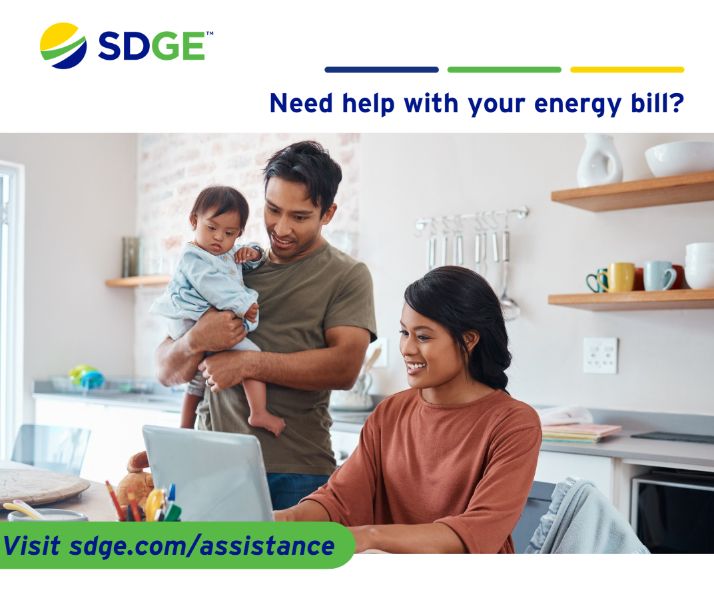
Business articles + social posts
Article: SMART ENERGY TIPS FOR BUSINESSES
Small changes to everyday equipment and settings can make a big difference in your business’s energy use. The tips below offer practical ways to reduce energy waste, improve comfort and keep your building systems running efficiently.
- Right-size your HVAC.
Oversized or undersized units can waste energy. Have a pro confirm your system matches your building’s square footage, layout and use patterns.
- Clean refrigerator coils.
Breakroom fridges work harder when the coils collect dust. A quick, quarterly cleaning can reduce energy use and extend appliance life.
- Use ceiling fans wisely.
Reverse fans to clockwise in cooler months to push warm air down, reducing heating needs.
- Optimize computer and server settings.
Enable energy-saving modes, adjust displays to auto-sleep and consolidate servers where possible.
- Install window film.
Solar-control films help regulate indoor temperatures by reducing heat gain and glare—great for sunny offices.
- Use plug-in space heaters sparingly.
They’re extremely energy-intensive. Offer warm layers or provide central heating adjustments instead.
- Add insulation to water heaters and pipes.
Insulating materials help retain heat and reduce energy loss, especially in older buildings.
- Calibrate building control systems.
Ensure automated controls—like lighting and HVAC timers—actually match your current operating hours.
- Prioritize preventative maintenance.
Regular tune-ups on motors, compressors and pumps prevent inefficiencies from sneaking in.
- Choose laptop-first over desktop-first.
Laptops use significantly less energy than desktop computers.

Energy efficiency doesn’t require major upgrades; just consistent attention to how your workspace operates. By taking a few simple steps, you can cut costs, extend equipment life and create a more comfortable environment for everyone. Discover more energy-saving tips for your business at sdge.com/MyBusiness.

Actual savings obtained in each instance may vary and will depend on various factors, including geographic location, weather conditions, equipment installed, usage rates and so forth. Completing multiple energy-saving measures will not necessarily result in cumulative savings.

Social posts: SMART ENERGY TIPS FOR BUSINESSES
Use any of the above tips and add, “Visit sdge.com/MyBusiness for more helpful energy-saving tips. #sdge #SDGEassist”
Example:
Prioritize preventative maintenance. Regular tune-ups on motors, compressors and pumps prevent inefficiencies from sneaking in. Visit sdge.com/MyBusiness for more helpful energy-saving tips. #sdge #SDGEassist



