

# Residential and small business community outreach package

# March 2025

As a trusted community member, we thank you for sharing our content and digital assets with your audiences – including residents, customers and employees – to help amplify our key messages in your email communications, websites, newsletters and social media.

# Best practices when using SDG&E’s content



**SDG&E logo**

You’re welcome to mention our name but, due to legal requirements, **please do not use our logo** **in any marketing materials that you create**. It’s okay to reshare our public posts which you’ll find on [***Facebook.com/sdge***](https://www.facebook.com/search/top?q=san%20diego%20gas%20%26%20electric), [***Instagram.com/sdge***](https://www.instagram.com/sdge/)and [***X.com/sdge***](https://x.com/sdge)***.*** *The graphics we provide in this document for social posts include our logo and that is okay to include in your communications.*

**Videos**

We have a library of videos you can share in your communications when you visit [***youtube.com/c/SanDiegoGasElectric/videos***](https://www.youtube.com/c/SanDiegoGasElectric/videos). If you’d like to sort our videos by topic, visit [***youtube.com/c/SanDiegoGasElectric***](https://www.youtube.com/c/SanDiegoGasElectric). Some videos are in Spanish. You’ll see some on TV, too!

**Follow us**

Find us on [**Facebook**](https://www.facebook.com/SanDiegoGasandElectric)**,** [**Instagram**](https://www.instagram.com/sdge)**,** [**X**](https://x.com/SDGE)**,** [**YouTube**](https://www.youtube.com/sandiegogaselectric)and [**LinkedIn**](http://linkedin.com/company/sdge). When sharing our digital assets and content, feel free to tag SDG&E’s social media and direct your audience to [***sdge.com***](https://www.sdge.com/).

If you have any questions, comments or feedback, email Lynne Pelzek @ [***lpelzek@sdge.com***](mailto:lpelzek@sdge.com).

© 2025 San Diego Gas & Electric Company. All copyright and trademark rights reserved.

# This month’s topics:



How to save on natural gas costs; customer accessibility; assistance programs; business energy-saving tips

**Table of contents**

|  |  |  |
| --- | --- | --- |
| **Topics** | Articles | Social  Posts |
| Tips to use less natural gas and save on your energy bill (at home) | 4 – 5 | 5 – 6 |
| Accessible resources | 6 | 6 – 7 |
| Customer assistance programs | 7 – 8 | 8 – 9 |
| Tips to use less natural gas and save on your energy bill (businesses) | 9 – 10 | 11 |

**Residential articles + social posts**

**Article – Ten tips to use less natural gas and save on your energy bill**

Reducing natural gas use at home may contribute to energy savings and it’s better for the environment. Check out these energy-saving tips to help you save on your bill during the cold weather:

# Block the chill.

# Caulk and weather-strip around drafty doors and windows. Use a door sweep, door sock or towel at the bottom of doors with a gap.  Also remember to shut your chimney flue when not in use to prevent warm air from escaping.

# Keep your furnace and air filters clean.

# Check furnace filters once a month and replace them regularly. A dirty air filter can increase your energy costs and cause problems with your equipment.

# Set your ceiling fan to run clockwise.

# This causes the fan to produce an updraft, forcing the hot air that rises to your ceiling down and into the rest of the room. In the summer, you can switch the fans to counterclockwise to keep the room cool.

# Schedule a no-cost gas appliances check with SDG&E.

# Book an appointment online at [MyEnergyCenter.com](https://myenergycenter.com/). Select the Services tab, Services Overview and then Gas Appliances Check. Learn more at [*sdge.com/GasCheck*](https://www.sdge.com/residential/customer-service/service-requests/gas-appliance-check).

# Lower your thermostat.

Try lowering your thermostat a few degrees and throwing on a cozy sweater and socks or cuddling with your fur baby! You can also invest in a smart thermostat. Rebates are available at [***sdge.com/rebates***](https://www.sdge.com/rebates).

# Lower your water heater thermostat.

# Lowering the thermostat on your water heater to 120°F, if possible, will save energy and avoid scalding. Find water heater rebates from $75 to $500 at [*sdge.com/rebates*](https://www.sdge.com/rebates).

1. **Use the “energy saver” switch on your dishwasher.**

Set it on a low temperature setting when feasible. Also, think about turning off the heat drying cycle – you don’t need it! Only run full loads and turn the appliance off after the dishes are washed. And make sure to run it during off-peak hours **before 4 p.m. or after 9 p.m**.

1. **Keep your blinds and curtains open during the day and closed at night**.

During the day, let the sunlight and warmth in. When the sun goes down, close your blinds to keep the warm air in.

1. **Make sure your home is well-insulated**.

Without good home insulation, the hot air your natural gas heating system emits can escape through cracks, doors, windows, the attic and garage.

1. **Use water efficiently**.

Take shorter showers and wash clothes in cold water. Consider installing low-flow fixtures, insulating your hot water pipes and using a water heater timer.

Visit [***sdge.com/winter***](https://www.sdge.com/winter) for more bill-saving and energy management resources.

# *Actual savings may vary and will depend on various factors, including geographic location, weather conditions, equipment installed, usage rates and similar factors.*

**Social posts – Ten tips to use less natural gas and save on your energy bill**

Use any of the tips in the above article, then add:

Visit [***sdge.com/winter***](https://www.sdge.com/winter)for additional winter energy-savings tips. #sdge #SDGEassist

Example:

Keep your blinds and curtains open during the day and closed at night. During the day, let the sunlight and warmth in. When the sun goes down, close your blinds to keep the warm air in.  Visit [***sdge.com/winter***](https://www.sdge.com/winter) for more bill-saving and energy management resources.  #sdge #SDGEassist

# Article – SDG&E’s accessible information, resources and services

# SDG&E is committed to supporting customers and making sure that everyone is offered equal access to information, resources and services. To learn more, visit [*sdge.com/AFN*](https://www.sdge.com/access-and-functional-needs-afn). Customers are also encouraged to share their household’s individual needs using the form found at[*sdge.com/AFN-survey*](https://www.sdge.com/access-and-functional-needs-survey).

Let us know whether you or someone in your household:

1. Has a disability;
2. Uses an electronic medical device for health, safety or independence;
3. Is blind or has low vision;
4. Is deaf or hard of hearing; and/or
5. Requires the use of assistive technology or durable medical equipment.

# Social posts – SDG&E’s accessible information, resources and services

1. SDG&E is committed to supporting their customers with access and functional needs and making sure that everyone is offered equal access to information, resources and services. Learn more at [***sdge.com/AFN***](https://www.sdge.com/access-and-functional-needs-afn). #sdge #SDGEassist
2. SDG&E is committed to providing all customers with accessible resources and services. To learn more, visit [***sdge.com/AFN***](https://www.sdge.com/access-and-functional-needs-afn). #sdge #SDGEassist



**Article – Energy bill assistance programs: Help is available**

Managing energy bills can be challenging in cold weather. But did you know that SDG&E offers several assistance programs to help customers reduce their energy costs and improve energy efficiency?

1. **California Alternate Rates for Energy (CARE) Program**

The CARE program provides a 30% or more discount on monthly energy bills for eligible households. Eligibility is based on household size and income, or participation in certain public assistance programs. Applying is quick and easy, with no documentation required. Find out if you qualify at [***sdge.com/CARE***](https://www.sdge.com/residential/pay-bill/get-payment-bill-assistance/assistance-programs).

1. **Family Electric Rate Assistance (FERA) Program**

FERA offers an 18% discount on electric bills for households with three or more people who exceed CARE income limits but still meet FERA guidelines. This program helps larger families manage their energy expenses more effectively. Learn more at [***sdge.com/FERA***](https://www.sdge.com/FERA).

1. **Energy Savings Assistance (ESA) Program**

The ESA program provides no-cost energy-efficient home improvements to income-qualified customers. Services and products may include attic insulation,

energy-efficient refrigerators, weatherstripping and more. The program aims to reduce energy use and help lower bills. Find details at [***sdge.com/ESA***](https://www.sdge.com/residential/pay-bill/get-payment-bill-assistance/assistance-programs/no-cost-energy-efficient-home-improvements).

1. **Medical Baseline Allowance**

Customers with certain medical conditions may qualify for additional energy at the lowest rates through the Medical Baseline Allowance program. This helps offset the cost of operating medical equipment or maintaining necessary heating and cooling. Learn more at [***sdge.com/Medical***](https://www.sdge.com/residential/pay-bill/get-payment-bill-assistance/health-senior-support/qualifiying-based-medical-need)*.*

1. **Payment Arrangements**

If you’re having trouble paying your energy bill, you can request an extension to help avoid interruptions to your service. Flexible payment arrangements are also available to help you pay down past due balances. Learn more at [***sdge.com/PaymentArrangements***](https://www.sdge.com/residential/pay-bill/payment-arrangements).

Learn about these programs and more at [***sdge.com/assistanc***](https://www.sdge.com/residential/pay-bill/get-payment-bill-assistance)***e.***

# Social posts – Energy bill assistance programs: Help is available

1. Hardship can hit at any time – when it does, the last thing you need to worry about is your energy bill. Get help with your bill at [***sdge.com/assistance***](https://www.sdge.com/residential/pay-bill/get-payment-bill-assistance). #sdge #SDGEassist
2. SDG&E offers assistance programs to help you with your monthly energy bill which could include up to a 30% discount. Find out if you qualify at [***sdge.com/assistance***](https://www.sdge.com/residential/pay-bill/get-payment-bill-assistance). #sdge #SDGEassist
3. Whether you rent or own, you could be eligible to receive no-cost, energy-efficient home improvements that can make your home more comfortable and help reduce your energy bill. Find out if you qualify at [***sdge.com/ESA***](https://www.sdge.com/residential/pay-bill/get-payment-bill-assistance/assistance-programs/no-cost-energy-efficient-home-improvements). #sdge #SDGEassist

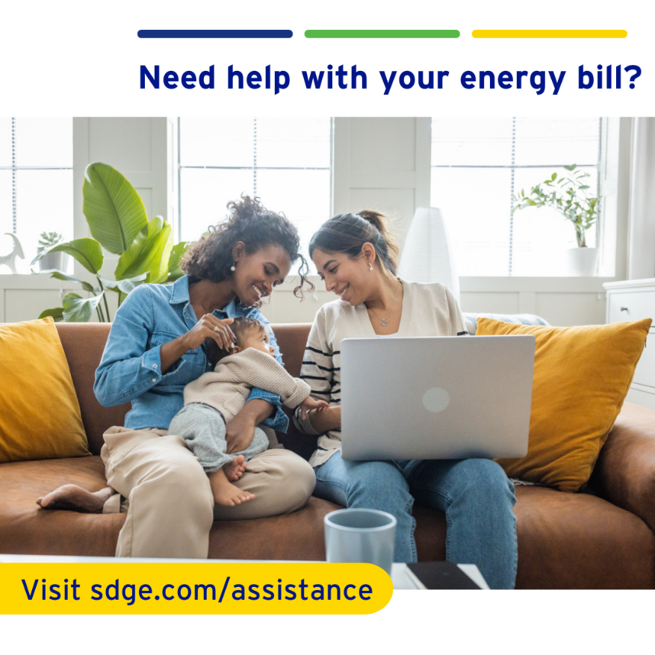

# Business article + social posts

# Article – How your business can save on natural gas costs

It's important for businesses to be both eco-friendly and cost-effective. Saving natural gas is a smart move! From using energy-efficient technologies to making simple changes in how things are done every day, these ideas can guide businesses towards a more planet- and budget-friendly path.

1. **Understand your gas consumption.**

Monitor your gas consumption with [***MyEnergyCenter.com***](https://myenergycenter.com/) to identify peak usage periods and discover opportunities to reduce your energy use during those times. Click on the **usage** tab at the top, then on the right side of the next screen, click on the **meter drop down button** to toggle between electric and natural gas use.

1. **Get a tune-up on your heater to ensure your system is operating efficiently**.

New, clean air filters can improve airflow and heating. Check out these water heater rebates up to $500 on the purchase of new, qualifying energy-efficient gas water heaters at [***sdge.com/rebates***](https://www.sdge.com/rebates).

1. **Add weatherstripping, caulking or foam insulation around windows and doors to help reduce drafts.**

Caulk ducts, plumbing openings, recessed lighting fixtures and other spaces that leak air into walls, floors and ceilings.

1. **Check your HVAC filters monthly and clean them or replace them if they are dirty.**

Keeping your HVAC system properly maintained can help save on heating costs.

1. **Seal and insulate air ducts.**

This can help improve your system’s efficiency and enhance indoor air quality. Sealed ducts help prevent pollutants and allergens from entering your HVAC system and circulating throughout your space.

1. **Change the rotation of your ceiling fans**.

Did you know ceiling fans help in the colder months too? Change the direction of your fan blades to clockwise. This pulls the warm air down and spreads it throughout the room.

1. **Lower your office’s temperature**.

Your business can keep comfortable without cranking up the heat. Don’t turn off your heat overnight though – you’ll use more energy to heat the building again in the morning. Find rebates on smart thermostats at [***sdge.com/rebates***](https://sdge.com/rebates).

1. **Use heat recovery systems**.

Implement heat recovery systems to capture and reuse waste heat from industrial processes or HVAC systems.

1. **Optimize your water heating.**

Lower the temperature on your water heater and insulate hot water pipes to reduce energy use. Check out available water heater rebates at [***sdge.com/rebates***](https://sdge.com/rebates)***.***

1. **Invest in energy-saving equipment.**

When it’s time to buy new equipment, opt for those that are more energy efficient. Look for the light blue ENERGY STAR® label.

# Visit [*sdge.com/MyBusiness*](https://www.sdge.com/business/savings-center/business-winter-savings-safety-and-solutions) for more helpful energy-saving tips, tools and programs for your business.

# *Actual savings may vary and will depend on various factors, including geographic location, weather conditions, equipment installed, usage rates and similar factors.*

# Social posts – How your business can save on natural gas costs

Use any of the tips above and then add:

Visit [***sdge.com/MyBusiness***](https://www.sdge.com/business/savings-center/business-winter-savings-safety-and-solutions) for more helpful energy-saving tips. #sdge #SDGEassist

Example:

Use heat recovery systems. Implement heat recovery systems to capture and reuse waste heat from industrial processes or HVAC systems. Visit [***sdge.com/MyBusiness***](https://www.sdge.com/business/savings-center/business-winter-savings-safety-and-solutions) for more helpful energy-saving tips. #sdge #SDGEassist

