

# Residential and small business community outreach package

# May 2025

As a trusted community member, we thank you for sharing our content and digital assets with your audiences – including residents, customers and employees – to help amplify our key messages in your email communications, websites, newsletters and social media.

# Best practices when using SDG&E’s content



**SDG&E logo**

You’re welcome to mention our name but, due to legal requirements, **please do not use our logo** **in any marketing materials that you create**. It’s okay to reshare our public posts which you’ll find on [***Facebook.com/sdge***](https://www.facebook.com/search/top?q=san%20diego%20gas%20%26%20electric), [***Instagram.com/sdge***](https://www.instagram.com/sdge/)and [***X.com/sdge***](https://x.com/sdge)***.*** *The graphics we provide in this document for social posts include our logo and that is okay to include in your communications.*

**Videos**

We have a library of videos you can share in your communications when you visit [***youtube.com/c/SanDiegoGasElectric/videos***](https://www.youtube.com/c/SanDiegoGasElectric/videos). If you’d like to sort our videos by topic, visit [***youtube.com/c/SanDiegoGasElectric***](https://www.youtube.com/c/SanDiegoGasElectric). Some videos are in Spanish. You’ll see some on TV, too!

**Follow us**

Find us on [**Facebook**](https://www.facebook.com/SanDiegoGasandElectric)**,** [**Instagram**](https://www.instagram.com/sdge)**,** [**X**](https://x.com/SDGE)**,** [**YouTube**](https://www.youtube.com/sandiegogaselectric)and [**LinkedIn**](http://linkedin.com/company/sdge). When sharing our digital assets and content, feel free to tag SDG&E’s social media and direct your audience to [***sdge.com***](https://www.sdge.com/).

If you have any questions, comments or feedback, email Lynne Pelzek @ [***lpelzek@sdge.com***](mailto:lpelzek@sdge.com).

© 2025 San Diego Gas & Electric Company. All copyright and trademark rights reserved.

# This month’s topics:



Earthquake readiness; new energy bill payment options; customer assistance programs; small business energy-saving tips

**Table of contents**

|  |  |  |
| --- | --- | --- |
|  | Articles | Social  Posts |
| Earthquake preparedness | 4 – 5 | 5 – 6 |
| New ways to pay your energy bill | 6 – 7 | 7 – 8 |
| Energy bill assistance programs | 8 – 9 | 9 – 10 |
| Energy-saving tips for Businesses | 11 – 12 | 13 – 14 |

**Residential articles + social posts**

**Article: ARE YOU PREPARED FOR AN EARTHQUAKE?**

Living in Southern California means earthquakes can happen at any time, so it's crucial to have an emergency plan ready. It's easy to get complacent with frequent warnings, but being prepared can save lives. Here are some tips from SDG&E to help you respond quickly and keep your loved ones safe in case of a major earthquake.

1. Develop an evacuation plan. Create an evacuation plan that includes multiple escape routes and meeting places outside your home. Practice the plan with your family, including pets and livestock. For personalized tips, visit [***sdge.com/checklist***](https://www.sdge.com/more-information/safety/emergency-preparedness/emergency-checklists)***.***
2. Review your emergency plans. Familiarize yourself with emergency plans at your workplace, school or other places where you or your family spend time regularly.
3. Pack an emergency kit. Assemble a backpack with essential items such as non-perishable foods, bottled water, a first aid kit, flashlight, cash, pet food, manual can opener, medications, an overnight bag with clothes and toiletries and a portable radio with fresh batteries. For more ideas, visit [***sdge.com/checklist***](https://www.sdge.com/more-information/safety/emergency-preparedness/emergency-checklists)***.***
4. Update your contact info. Ensure your contact information with SDG&E is current. Update or confirm your info at [***MyEnergyCenter.com***](https://myenergycenter.com/).  After logging in, select **Account** and then **Notification Settings**.
5. Sign up for alerts. Register for SDG&E power outage alerts. Learn more at [***sdge.com/notifications***](https://www.sdge.com/notifications) or login to [***MyEnergyCenter.com***](https://myenergycenter.com/). Select **Account**, **Notification Settings** and then **Outages & Gas Leaks**.
6. Secure your space: Walk through your home to identify items that could fall when shaken, then secure those items. Move heavy or large items, like potted plants, to the floor or low shelves and away from escape routes. You can also secure your water heater to the wall, install earthquake shut-off valves, install latches on kitchen cabinets and brace electronic items like TVs with straps. For more ideas, visit [***EarthquakeCountry.org***](https://www.earthquakecountry.org/library/StayingSafeWhereTheEarthShakes_StatewideEdition.pdf).

In the event of an earthquake or other natural disaster:

1. Remember to drop, cover and hold on. Drop down onto your hands and knees, cover your head and neck with your hands and arms and take shelter under a sturdy table or desk, if possible. Hold on to your shelter until the shaking stops. If you’re outside, move away from buildings, trees, power lines or under freeway overpasses. If you’re at the beach, move to higher ground.
2. Stay away from downed power lines and trees. Do not touch downed power lines or broken gas lines, and call SDG&E when it’s safe to do so.
3. If you are indoors, **do not run outside**. This is dangerous as you can easily fall or be injured by falling objects and debris like glass, bricks and other building components.
4. Do not use flames. Use flashlights instead of lanterns, matches or candles.

**Social posts: ARE YOU PREPARED FOR AN EARTHQUAKE?** 

1. Are you ready for an emergency? Develop an evacuation plan at home that includes more than one escape route. Practice the plan with your family and loved ones, including pets and livestock. Get helpful tips on how to prepare for an emergency at [***sdge.com/emergency***](https://www.sdge.com/gas-electric-emergency-preparedness). #sdge #SDGEassist
2. Are you prepared for an earthquake? Create an evacuation plan, assemble a backpack with essential items including water, food and medications. Don’t forget about your pets’ needs too. Ensure SDG&E has your current contact information and sign up for alerts at [***MyEnergyCenter.com***](https://myenergycenter.com/). #sdge #SDGEassist
3. Be prepared in case of an earthquake or other natural disaster. Walk through your home to identify items that could fall when shaken, then secure those items. You can also secure your water heater to the wall, install earthquake shut-off valves, install latches on kitchen cabinets and brace electronic items like TVs with straps. For more safety ideas, visit [***EarthquakeCountry.org***](https://www.earthquakecountry.org/library/StayingSafeWhereTheEarthShakes_StatewideEdition.pdf). #sdge #SDGEassist



**Article: Use your digital wallet to pay your energy bill**

Did you know that you can pay your energy bill conveniently with your digital wallet now? It’s easy to use Apple Pay®, Google Pay™, Venmo® and PayPal®. Just log in or sign up on [***MyEnergyCenter.com***](https://myenergycenter.com/) or the My Energy Center mobile app.

Here are convenient ways to pay your energy bill:

**Pay online:** You can pay online with a credit/debit card or electronic check, or with one of the new digital payment options(Apple Pay®, Google Pay™, Venmo® and PayPal®) by visiting [***MyEnergyCenter.com***](https://myenergycenter.com/) or the My Energy Center mobile app.

**Pay with Guest Pay**: Make a quick, one-time payment without entering your account number. Just go to [***sdge.com/PayBill***](https://www.sdge.com/residential/pay-bill/my-bill) and choose **Guest Pay**.

* **Pay by phone**: Call SDG&E at ***1-800-411-SDGE (7343)*** to pay by phone with a credit/debit card or electronic check.
* **Set up Auto Pay**: Never forget to pay your bill and make timely payments every month with your bank account. Sign up at [***MyEnergyCenter.com***](https://myenergycenter.com/). Log in, select **Billing,** then **Auto Pay**. You get to choose the payment schedule.
* **Explore additional options**: Visit [***sdge.com/PayBill***](https://www.sdge.com/residential/pay-bill/my-bill) for more information and payment options.

If you still receive a paper bill and pay by mail, consider switching to paperless billing. You can clear the clutter, save a stamp, reduce your carbon footprint and it’s safe and secure. Log in to [***MyEnergyCenter.com***](https://myenergycenter.com/) and select **Account,** then **My Profile**. Scroll to the bottom of the page and click on **Sign Up** under **Paperless Billing**.

**Social posts: Use your digital wallet to pay your energy bill**

1. Did you know you can now pay your energy bill with your digital wallet?! Use Apple Pay®, Google Pay™, Venmo®, or PayPal®. Visit [***MyEnergyCenter.com***](https://myenergycenter.com/) or download the My Energy Center mobile app to get started. #sdge #SDGEassist
2. Convenience at your fingertips! Pay your energy bill online with new digital payment options like Apple Pay®, Google Pay™, Venmo® and PayPal®. Log in or sign up at [***MyEnergyCenter.com***](https://myenergycenter.com/) or the mobile app. #sdge #SDGEassist
3. Go paperless! Switch to paperless billing to clear the clutter, save a stamp, and reduce your carbon footprint. Learn more at [***sdge.com/paperless***](https://www.sdge.com/residential/pay-bill/go-paperless). #sdge #SDGEassist

A person in a wheelchair using a laptop computer



**Article: Energy bill assistance programs: Help is available**

Managing energy bills can be challenging. But did you know that SDG&E offers several assistance programs to help customers reduce their energy costs and improve energy efficiency?

1. **California Alternate Rates for Energy (CARE) Program**

The CARE program provides a 30% or more discount on monthly energy bills for eligible households. Eligibility is based on household size and income, or participation in certain public assistance programs. Applying is quick and easy, with no documentation required. Find out if you qualify at [***sdge.com/CARE***](https://www.sdge.com/residential/pay-bill/get-payment-bill-assistance/assistance-programs).

1. **Family Electric Rate Assistance (FERA) Program**

FERA offers an 18% discount on electric bills for households with three or more people who exceed CARE income limits but still meet FERA guidelines. This program helps larger families manage their energy expenses more effectively. Learn more at [***sdge.com/FERA***](https://www.sdge.com/FERA).

1. **Energy Savings Assistance (ESA) Program**

The ESA program provides no-cost energy-efficient home improvements to income-qualified customers. Services and products may include attic insulation,

energy-efficient refrigerators, weatherstripping and more. The program aims to reduce energy use and help lower bills. Find details at [***sdge.com/ESA***](https://www.sdge.com/residential/pay-bill/get-payment-bill-assistance/assistance-programs/no-cost-energy-efficient-home-improvements).

1. **Medical Baseline Allowance**

Customers with certain medical conditions may qualify for additional energy at the lowest rates through the Medical Baseline Allowance program. This helps offset the cost of operating medical equipment or maintaining necessary heating and cooling. Learn more at [***sdge.com/Medical***](https://www.sdge.com/residential/pay-bill/get-payment-bill-assistance/health-senior-support/qualifiying-based-medical-need)*.*

1. **Payment Arrangements**

If you’re having trouble paying your energy bill, you can request an extension to help avoid interruptions to your service. Flexible payment arrangements are also available to help you pay down past due balances. Learn more at [***sdge.com/PaymentArrangements***](https://www.sdge.com/residential/pay-bill/payment-arrangements).

Learn about these programs and more at [***sdge.com/assistanc***](https://www.sdge.com/residential/pay-bill/get-payment-bill-assistance)***e.***

# Social posts: Energy bill assistance programs: Help is available

1. Hardship can hit at any time – when it does, the last thing you need to worry about is your energy bill. Get help with your bill at [***sdge.com/assistance***](https://www.sdge.com/residential/pay-bill/get-payment-bill-assistance). #sdge #SDGEassist
2. SDG&E offers assistance programs to help you with your monthly energy bill which could include up to a 30% discount. Find out if you qualify at [***sdge.com/assistance***](https://www.sdge.com/residential/pay-bill/get-payment-bill-assistance). #sdge #SDGEassist
3. Whether you rent or own, you could be eligible to receive no-cost, energy-efficient home improvements that can make your home more comfortable and help reduce your energy bill. Find out if you qualify at [***sdge.com/ESA***](https://www.sdge.com/residential/pay-bill/get-payment-bill-assistance/assistance-programs/no-cost-energy-efficient-home-improvements). #sdge #SDGEassist

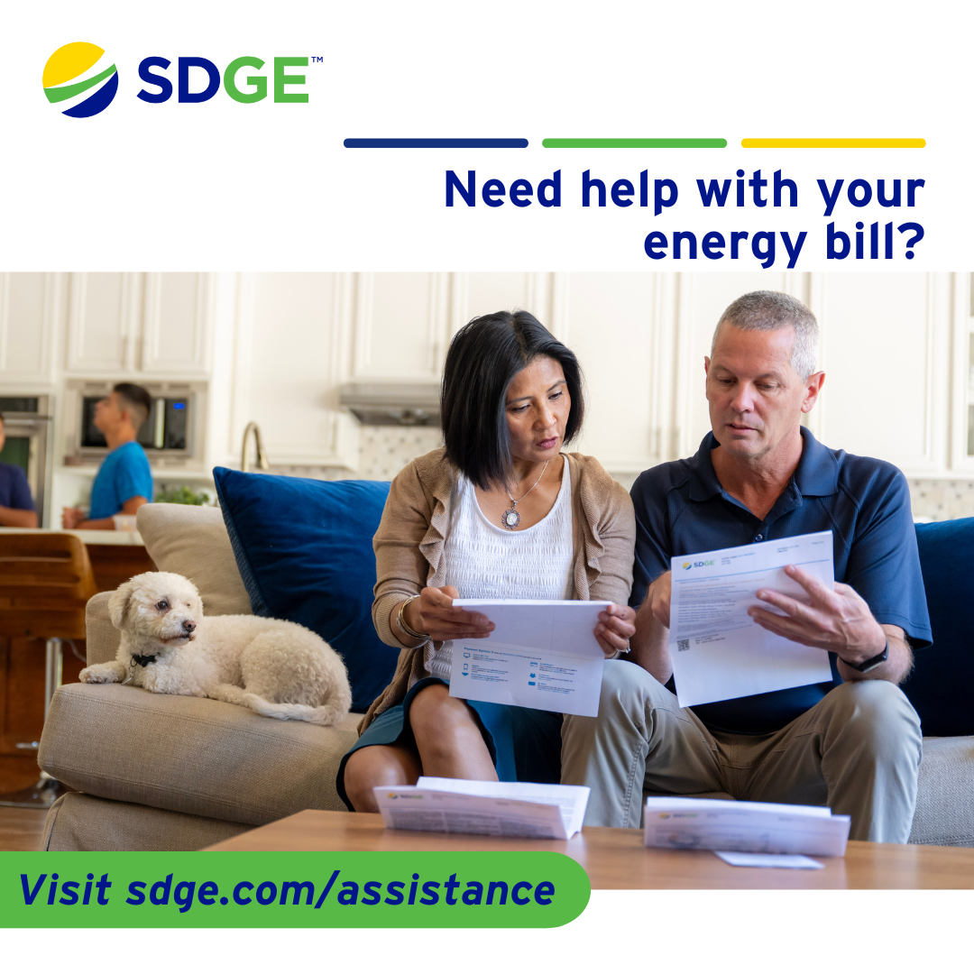

# Business article + social posts

# Article: Sealing in savings and comfort for your business

When it comes to the efficiency of your heating, ventilation and air conditioning (HVAC) system, one of the most overlooked factors is the condition of your ductwork. Not properly sealing your ducts can lead to a host of problems, from wasted energy to reduced comfort levels. Sealing those gaps is one of the cheapest and most effective ways to save on your energy bills and improve the comfort of your workspace.

**Finding leaks**

Start by locating where air leaks are occurring. It could be any place where two materials meet, such as the foundation walls and the flooring or where there's an opening to the outdoors. Gaps can also occur around exterior doors and cracked caulking around window frames. Another area to check is in the attic — gaps around ceiling fans, recessed light fixtures and electrical outlets.

**Fixing leaks**

If you find any leaks, sealing them is a simple project you can do yourself with supplies available from your local retailer.

1. **Windows**: Seal windows with exterior caulk. Your best bet is silicone or siliconized caulk.

* Where the window meets the frame, scrape out any existing caulk and make sure the area is clean and dry.
* Cut the tip of the caulk at a 45-degree angle and load it into the caulking gun.
* Run the tip slowly and evenly along the base of the crack.
* Finish by running a wet fingertip along the bead of the caulk to smooth it out.

1. **Doors**: Fix gaps around exterior doors with weatherstripping and a door sweep.

* Measure the top and sides of the door and cut pieces of weatherstripping to fit each.
* Peel back the covering from the adhesive and press the weatherstripping to the inside of the doorstop, ensuring a snug fit.
* Cut the sweep (if needed) to match the width of the door and attach it with adhesive or screws.

1. **Attic**: Ceiling fans, recessed lighting fixtures and electrical outlets in the ceiling below your attic are potential sources of air leakage.

* From the attic, pull back the insulation to find the cutouts and seal them with caulk or expandable foam.
* Check for and seal gaps around plumbing vents, furnace flues and ductwork.
* Seal the attic door or its access with weatherstripping.

**Additional spring energy-saving tips for businesses**

* Use natural light: Maximize natural light during the day to reduce the need for artificial lighting. Open curtains and blinds to let in sunlight, which can also help warm your workspace naturally.
* Use programmable thermostats: Install a programmable thermostat to automatically adjust the temperature when your business is closed. This can help reduce energy consumption and lower your energy bills.
* Maintain your cooling system: Regular maintenance of your air conditioning system ensures it runs efficiently. Clean or replace filters regularly and schedule professional check-ups.
* Use fans wisely: Ceiling fans can help circulate air and make your workspace feel cooler. Remember to turn them off when you leave the room, as fans cool people, not spaces.
* Invest in energy-efficient appliances: Consider upgrading to energy-efficient appliances, which use less energy and can save your business money in the long run.

Learn more about minimizing energy losses in ducts at [***energy.gov/EnergySaver***](https://www.energy.gov/energysaver/energy-saver). For more ways to save energy, visit [***sdge.com/MyBusiness***](https://www.sdge.com/business/savings-center/business-winter-savings-safety-and-solutions).

# *Actual savings may vary and will depend on various factors, including geographic location, weather conditions, equipment installed, usage rates and similar factors.*

# Social posts: Sealing in savings and comfort for your business

1. Seal those leaks! Properly sealing your ductwork can save energy and improve comfort in your workspace. Start by locating air leaks around windows, doors and in the attic. For more ways to save energy, visit [***sdge.com/MyBusiness***](https://www.sdge.com/business/savings-center/business-winter-savings-safety-and-solutions). #sdge #SDGEassist
2. Spring energy savings: Maximize natural light to reduce artificial lighting needs. Open curtains and blinds to let in sunlight and naturally warm your workspace. For more ways to save energy, visit [***sdge.com/MyBusiness***](https://www.sdge.com/business/savings-center/business-winter-savings-safety-and-solutions). #sdge #SDGEassist
3. Fix leaks: Sealing leaks around windows and doors is easy with caulk and weatherstripping. Improve your HVAC efficiency and save on energy bills! For more ways to save energy, visit [***sdge.com/MyBusiness***](https://www.sdge.com/business/savings-center/business-winter-savings-safety-and-solutions). #sdge #SDGEassist
4. Maintain your cooling system: Regular maintenance of your air conditioning system ensures it runs efficiently. Clean or replace filters and schedule professional check-ups. For more ways to save energy, visit [***sdge.com/MyBusiness***](https://www.sdge.com/business/savings-center/business-winter-savings-safety-and-solutions). #sdge #SDGEassist
5. Invest in energy-efficient products: Upgrade to energy-efficient appliances to save money and reduce energy consumption in the long run. For more ways to save energy, visit [***sdge.com/MyBusiness***](https://www.sdge.com/business/savings-center/business-winter-savings-safety-and-solutions). #sdge #SDGEassist

