


Residential and small business community outreach package

October 2026
We thank you, as one of our trusted community members, for sharing our content and digital assets with your audiences – including residents, customers and employees. Your email communications, websites, newsletters and social media help amplify our key messages.



Best practices when using SDG&E’s content

- SDG&E® logo
You’re welcome to mention our name; but, due to legal requirements, please do not use our logo in any marketing materials that YOU CREATE. It’s okay to reshare our public posts, which you’ll find on Facebook.com/sdge, Instagram.com/sdge and X.com/sdge. The graphics we provide in this document for social posts include our logo, and that is okay to include in your communications.

- Social posts
PLEASE ONLY USE THE INCLUDED SOCIAL POSTS IN THE SAME MONTH AS THIS PACKAGE

- Videos
We have a library of videos you can share in your communications when you visit youtube.com/c/SanDiegoGasElectric/videos. If you’d like to sort our videos by topic, visit youtube.com/c/SanDiegoGasElectric. Some videos are in Spanish. You’ll see some on TV, too!

- Follow us
Find us on Facebook, Instagram, X, YouTube and LinkedIn. When sharing our digital assets and content, feel free to tag SDG&E’s social media and direct your audience to sdge.com.

If you have any questions, comments or feedback, email Lynne Pelzek @ lpelzek@sdge.com.

Message funded by ratepayers.

© 2026 San Diego Gas & Electric® Company. All copyright and trademark rights reserved.

This month’s topics:
Energy-saving tips for residential and small/medium business customers, payment arrangements, customer assistance programs, pre-owned EV rebates

Table of contents
Article: Residential energy savings, p. 4
Social posts: Residential energy savings, p. 5
Article: Payment arrangements, p. 5
Social posts: Payment arrangements, p. 6
Article: Customer Assistance, pp. 6 – 7
Social posts: Customer Assistance, pp. 7 – 8
Social post: Pre-owned EV rebates, p. 8
Article: Business energy savings, p. 9
Social posts: Business energy savings, p. 10

Residential articles + social posts
Article: FALL ENERGY SAVINGS AND BILL SUPPORT RESOURCES
As temperatures begin to cool and households settle into fall routines, now is a good time to explore tools and programs that can help you better understand your energy use, manage costs and find bill assistance options.
SDG&E® offers a variety of resources designed to help you take control of your energy use and budget throughout the year.
Help With Energy Bills
It was a long, hot summer, and staying comfortable in the heat may have led to higher energy use and bills. Resources are available to help. Visit sdge.com/assistance to learn more about support options, including financial-assistance programs and flexible payment plans.
Stay Informed with Energy Alerts
Customized text and email alerts can help you keep track of your energy use and costs. Alerts can notify you when your energy usage reaches a certain level, when a bill reaches a specified amount or when a payment is coming due. Learn more and sign up at sdge.com/alerts.
Understand Energy Usage Patterns
You can gain valuable insights into how and when you use energy through My Energy Center. By logging in at MyEnergyCenter.com and selecting the "Usage" tab, you can view energy use by month, day, hour and even 15-minute intervals.
Take Advantage of Lowest-Cost Hours
Super off-peak hours, the time of day when energy costs the least, now include weekdays from 10 a.m. to 2 p.m., giving you more opportunities to save. Learn more at sdge.com/super-off-peak.
Running major appliances, charging electric vehicles or precooling your home from midnight to 6 a.m. and 10 a.m. to 2 p.m. on weekdays or midnight to 2 p.m. on weekends can help reduce energy costs.
For additional energy-saving tips and simple ways to lower energy use, visit sdge.com/SimpleSteps.

Social posts: FALL ENERGY SAVINGS AND BILL SUPPORT RESOURCES
- Fall is a great time to check out tools that can help you manage energy use, track costs and find bill assistance options. Learn more at sdge.com/SimpleSteps. #SDGE #SimpleSteps
- Stay informed with customized energy alerts. Get text or email notifications about energy use, bill amounts and payment reminders. Learn more at sdge.com/alerts. #SDGE #EnergyAlerts


Article: PAYMENT ARRANGEMENTS MAY HELP
Need more time to pay your energy bill? Payment arrangements can make it easier to manage your payments and avoid service interruptions. Depending on your account eligibility, you may be able to:
• Request a payment extension for extra time to pay your bill
• Set up a payment plan to spread bill payments over time
You can view and manage payment arrangements online through MyEnergyCenter.com or through the My Energy Center mobile app.
Learn more and explore your options at sdge.com/PaymentArrangements.
Social posts: PAYMENT ARRANGEMENTS MAY HELP
- Need more time to pay your energy bill? Eligible customers may quality for a payment extension or payment plan. Learn more at sdge.com/PaymentArrangements. #SDGE
- Payment arrangements can help you manage your energy bill and avoid service interruptions. Explore available options at sdge.com/PaymentArrangements. #SDGE

Article: Energy bill assistance programs: Help is available
Did you know that SDG&E® offers several assistance programs to help customers reduce their energy costs and improve energy efficiency?
- California Alternate Rates for Energy (CARE) Program
The CARE program provides a 30% or more discount on monthly energy bills for eligible households. Eligibility is based on household size and income, or participation in certain public-assistance programs. Applying is quick and easy, with no documentation required. Find out if you qualify at sdge.com/CARE.
- Family Electric Rate Assistance (FERA) Program
FERA offers an 18% discount on electric bills for households who exceed CARE income limits but still meet FERA guidelines. Households of one or two are now eligible. Learn more at sdge.com/FERA.
- Energy Savings Assistance (ESA) Program
The ESA program provides no-cost, energy-efficient home improvements to income-qualified customers. Services and products may include attic insulation,energy-efficient refrigerators, weatherstripping and more. The program aims to reduce energy use and help lower bills. Find details at sdge.com/ESA.
- Medical Baseline Allowance
Customers with certain medical conditions may qualify for additional energy at the lowest rates through the Medical Baseline Allowance program. This helps offset the cost of operating medical equipment or maintaining necessary heating and cooling. Learn more at sdge.com/medical.
- Payment Arrangements
If you’re having trouble paying your energy bill, you can request an extension to help avoid interruptions to your service. Flexible payment arrangements are also available to help you pay down past-due balances. Learn more at sdge.com/PaymentArrangements.
Learn about these programs and more at sdge.com/assistance.
Social posts: Energy bill assistance programs: Help is available
- Hardship can hit at any time – when it does, the last thing you need to worry about is your energy bill. Get help with your bill at sdge.com/assistance. #SDGE #SDGEassistance
- SDG&E® offers assistance programs to help you with your monthly energy bill, which could include up to a 30% discount. Find out if you qualify at sdge.com/assistance. #SDGE #SDGEassistance
- Whether you rent or own, you could be eligible to receive no-cost, energy-efficient home improvements that can make your home more comfortable and help reduce your energy bill. Find out if you qualify at sdge.com/ESA. #SDGE #SDGEassistance
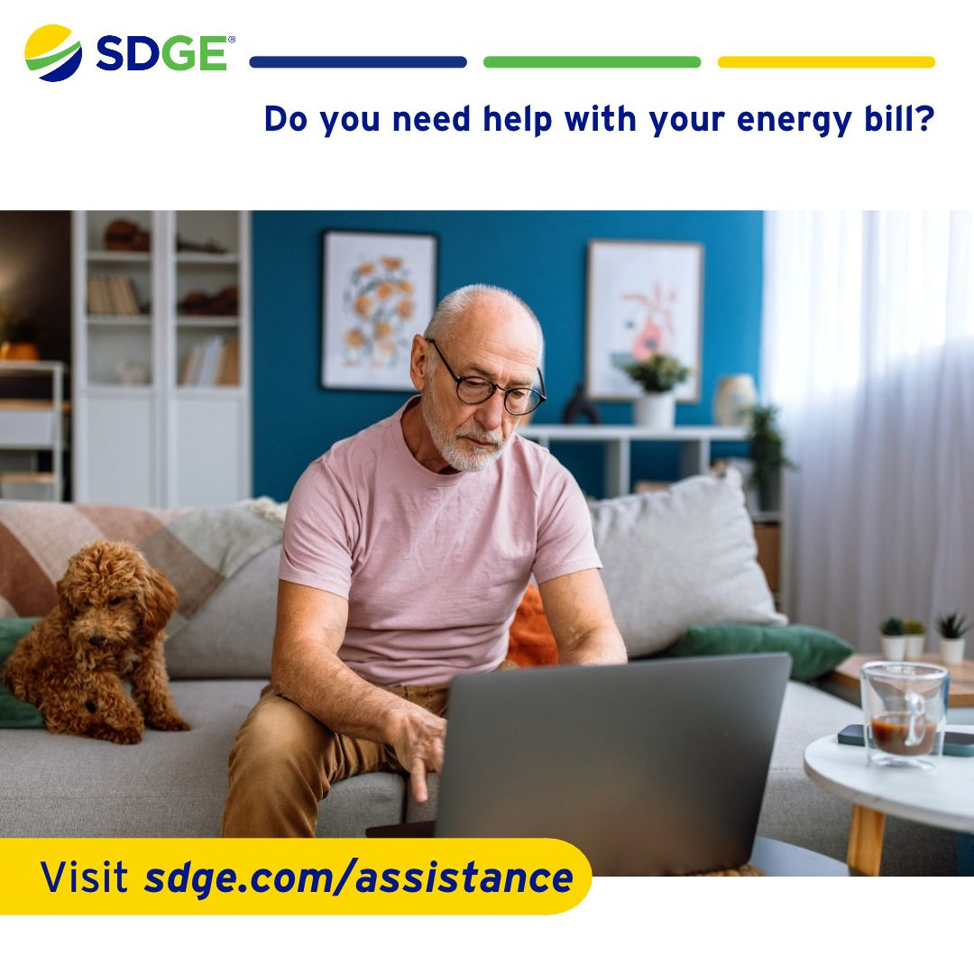

Social post: EV REBATES
Buying or leasing a pre-owned electric vehicle (EV)? You may be eligible for up to $4,000 in rebates based on household income. Learn more at sdge.com/GoPOEV. #SDGE #EVrebates

Business article + social posts
Article: FALL ENERGY-SAVING TIPS FOR BUSINESSES
As the seasons change and businesses prepare for the busy months ahead, fall is a good time to look for simple ways to manage energy use and reduce operating costs. Small changes can add up over time and help improve energy efficiency throughout the workplace.
Reduce costs with smart scheduling
When possible, shift energy-intensive activities such as EV charging, laundry, ice production and food preparation to lower-cost hours outside 4 to 9 p.m. Even small scheduling changes can help reduce energy costs over time.
Optimize energy use
Many devices continue using energy even when they are not actively being used. Turn off lighting, equipment and electronics when they are not needed, including in unoccupied breakrooms, bathrooms and hallways.
Pre-cool and save
When appropriate for your operations, pre-cool your business before 4 p.m. Then set the thermostat to 78° F or higher from 4 to 9 p.m., health permitting. Keep doors, windows and loading areas closed while cooling systems are running.
Stay on top of costs with Energy Alerts
Monitoring energy use can help businesses identify trends and opportunities for savings. Get text or email notifications when your energy use reaches a dollar amount you choose. Sign into MyEnergyCenter.com to set up alerts, review personalized energy insights and compare pricing plans. For additional energy-saving ideas and resources, visit sdge.com/MyBusiness.

*Actual savings obtained in each instance may vary and will depend on various factors, including geographic location, weather conditions, equipment installed, usage rates and so forth. Completing multiple energy-saving measures will not necessarily result in cumulative savings.

Social posts: FALL ENERGY-SAVING TIPS FOR BUSINESSES
- Small changes can make a difference. Shifting energy-intensive tasks to lower-cost hours may help reduce operating costs for your business. Learn more at sdge.com/MyBusiness. #SDGE
- Help lower energy costs by turning off lights, equipment and electronics when they aren't in use. Find more energy-saving tips at sdge.com/MyBusiness. #SDGE



